Digital Health Care Services using flutter

Ilapanda Abhilash#1, Dr. Vinay Singh*2

*#ABV-IIITM, Gwalior, India*

1img_2017026@iiitm.ac.in

*\*ABV-IIITM, Gwalior, India*

2vsingh@iiitm.ac.in

***Abstract*- —The Corona virus pandemic is causing great damage in developed countries with way better healthcare facilities, it will cause a much bigger impact in developing countries like India. Because of its high population, it faces several issues like shortage of medical personnel, medical facility assurance, corruption, insufficient funds for medical research etc. During this time, there have been several instances where patients were not admitted due to less number of beds, medical staff and it has caused many lives. The emergence of Web Services Technologies brings the chance to deal with the above challenges by using a new set of technological solutions. This paper proposes a Digital health care service (DHCS) which allows people to book an appointment according to their choice in a more convenient way. The main idea of this work is to provide ease and comfort to patients while taking appointments from doctors and it also resolves the problems that the patients do face while making an appointment. This application which is made on flutter acts as a client whereas the database containing the doctor’s details, patient’s details and appointment details is maintained by an internet site that acts as a server.**

***Keywords***- **Web Services Technology, Digital Health Care Services (DHCS), Server.**

1. Introduction

During this pandemic if anybody is unwell and needs to go to a doctor for a health scrutiny, it is very unlikely to get admitted and come out safe due to hospitals which are filled with covid patients or with inadequate no of beds. Even if he or she visits the hospital and waits in queue until the doctor is available. There is a chance that the doctor cancels the appointment for some emergency reasons then the patient isn’t able to comprehend the cancellation of the appointment instantly.

As the mobile communication technology is developing rapidly, therefore, one will use the mobile’s applications to beat such issues and inconvenience for the patients. An intelligent agent DHCS has been proposed in which a scheduling system is provided for patients. The junior medical employees schedule appointments as per the priority level. Searching doctors and hospitals along with navigation details are also available in the app so they can get proper treatment on time. It provides associate settings to interact with the doctors on their own mobile terminals, while doctors can track patients whenever and wherever possible or make a diagnosis of alert depending on the data they have.

This project is developed using flutter software development kit which resolves the above issues, gives a better user experience and saves a lot of time.

1. PURPOSE OF THE STUDY
2. *Background and Motivation*

Medical practices store paper medical records in massive warehouses. These paper records take up space and are less environmentally friendly, paper records additionally tend to deteriorate over time. Electronic medical records can be stored in the cloud allowing the use of fewer resources [5]. E-health care shares electronic data with patients and alternative clinicians. It helps effectively diagnose patients, scale back medical errors, and provide safer care [6]. While the Corona virus pandemic is causing great damage in developed countries with way better healthcare facilities, it will cause a bigger impact in developing countries like India. India being the 2nd most populated country produces around 50,000 doctors per year [15]. But due its high population, it faces many problems like shortage of medical personnel, medical facility assurance, corruption, insufficient funds for medical research etc. The doctor-population ratio in India is 1:1456 which is against WHO recommendation [13]. Due to this many people are dying because of the unavailability of the medical facilities [14]. This application can increase the efficiency and effectiveness of clinicians in examining the patients as there is no waiting time here and patients can consult doctors in a schedule which reduces the patient’s traffic and makes it simple. The evolution of web service technology in mobile provides [20] the platform to act and schedule appointments with prior notice and saves plenty of time for patients. We propose an approach to solve these problems using Web Service application. Specifically, we will use flutter for crafting these apps as we can make both android and ios apps with a single code base.

1. *Literature Review*

“Application of Intelligent Agents in Hospital Appointment Scheduling System” has proposed a system in which a scheduling system is provided for patients [1]. ”Android Application for Healthcare Appointment Booking” has been developed to make appointments online [2]. It describes an idea about a web based platform to support making online, cloud computing and android programs for hospitals and medical systems. “Functional Description of Online Medical Management System Using Modern Technology” manages the schedule of doctors, maintaining the records of patients etc [3]. ”Outpatient Satisfaction and Quality of Health Care in North Indian Medical Institute” fulfills the need to monitor the quality of care and patient satisfaction for continuous quality improvement[4].It can store the medical report of the patients in the application itself[9]. It is very cost effective and can get high quality health informative [10, 11]. “Embedded Management System for Out Patient Department” provides the facility for patients to locate their respective doctor’s cabin due to multiple consultants and more patients in the hospital [12]. ”Health Track: Health Monitoring and Prognosis System using Wearable Sensors” give the users an alert based on preset specified time before the appointment time and date. A Health Track system that communicates with sensors via smart phone for data collection is proposed [16]. “Intelligent Mobile Hospital Appointment Scheduling and Medicine Collection” proposes patient appoint scheduling and medicine collection system. This system is not supporting for walk in patients as well as cancellation and rescheduling of appointment [17]. Stores the medical data of the patient in the application itself which gets out from losing the medical reports [22] or getting misplaced somewhere. A versatile low cost mobile health care monitoring system using an android application [27] is designed which gives medication reminder [28]. A Smartphone based application to improve the health care system [29, 30] which we can operate just by sitting at home. This application puts efforts in solving the above issues in background and in literature review.

1. METHODOLOGY

This proposed system provides a platform for doctors and patients to interact with each other with minimal time loss and in an efficient way. The users will first have to download the application from Google Play store or app store and install it on their mobile devices. After opening the application, the user has to sign up for the first time. From then he can login using his password.

1. *System Overview*

This section describes the overview of our project precisely. First we need to set up environment dependencies; this requires visual studio code or Android studio, and flutter as an editor for the application. Then we have to get dart and flutter plug-in from extensions to write code here. Next, we have to write dart code in the flutter application [7, 8]. Flutter is merely full of widgets, so we have to use the widgets while writing the code for this. Next, we have to create UI for home page and other screens. Now we have to collect all the data required for this, and create a database to store our data. Next, we optimize the code and ready to debug. After debugging the code we run this in an android device or in an emulator. Finally we install the APK in the device to use it.

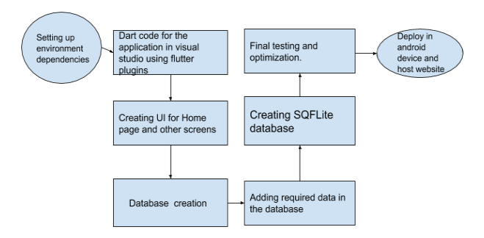

**Fig. 1 System Overview**

1. *Workflow*

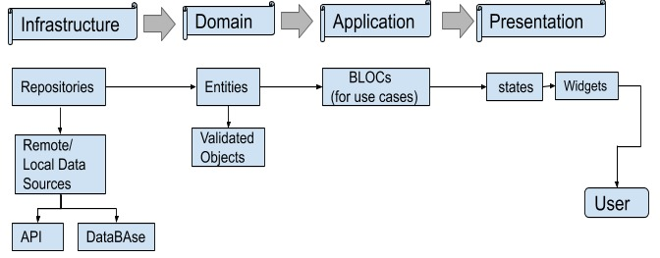

**Fig. 2 Workflow**

As you can see from the figure above, there are 4 levels in the architecture of the Workflow: Data, Domain, Application and Presentation. Each of them has its own purpose and only can interact like the flow above [23, 24, 25, 26]. It stores data in remote/local data sources which we give and then through these levels at last the user is able to see the widgets displaying it.

*C. Method Overview*

In the Home Screen, there is an option for all other functional screens like specialization, appointment, profile etc. On clicking make an appointment icon, it will redirect to the appointment screen where it will ask you about specialization, location, gender to make the appointment

To make an appointment, the patient has to select the type of doctor he needs then the doctor list will appear. After that select any particular doctor according to his requirement and view his profile. The patient will then send a request for appointment; the hospital staff can either accept the appointment or reject it according to the doctor’s schedule. The database will get updated accordingly and the patient will get a notification on his mobile device. The user can see his appointment status inside the application status bar on the home screen. He can also set reminders for the appointment using Google calendar.

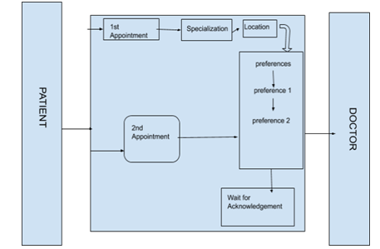

**Fig. 3 Method Overview**

Here preference 1 - Govt. or Pvt. Hospitals

Preference 2 - Gents or lady doctor

We can even add more preferences according to the patient’s needs. The Fig3 depicts the method overview of this application. There are two panels, Patient’s panel and Doctor’s panel in between for communication. To make an appointment he or she has to click on the appointment icon which redirects it to appointment screen where he has to choose the type of consultant he need. Then he has to choose the specialization and location, he can even have more preferences that is the gender of the consultant and the type of doctor.

To deploy DHCS application in android and iOS requires lot of time as we have to write the code separately for each. In flutter we write the custom dart code for the application, then this code through channels call to a receiving event handler in Kotlin (Android) or Swift (iOS) as shown in the fig4.

It gives best user interface because of Ahead Of Time compilation feature of flutter which let’s user a smooth and fast user experience [21]. And it is also very helpful for developers due to its Just In Time compilation which allows faster compilation process.

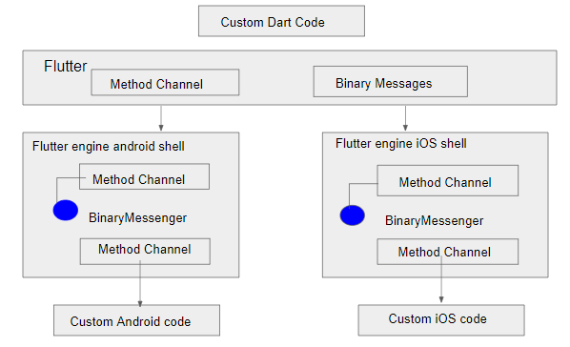

**Fig. 4 Deployment of DHCS [18]**

*D. Database Information*

We use database to store the data. To synchronize data between devices, we use SQLite Firebase database. In general, databases provide faster inserts, updates, and queries compared to other local persistence solutions.

SQLite is an open-source, zero-configuration, self-contained, stand-alone, transaction relational database engine designed to be embedded into an application.

Flutter supports an open source module SQFlite. It is a way of storing app data in flutter application. SQFlite is a Database plug-in for flutter. It is highly reliable and embedded Database engine. Flutter apps can make use of the SQLite databases via the SQFlite plug-in available on pub.dev. It also supports transaction and batches. Data manipulation techniques like insert/query/ update/delete queries can be done. Database operations can also be executed in background thread on both ios and Android making it more responsive UI.

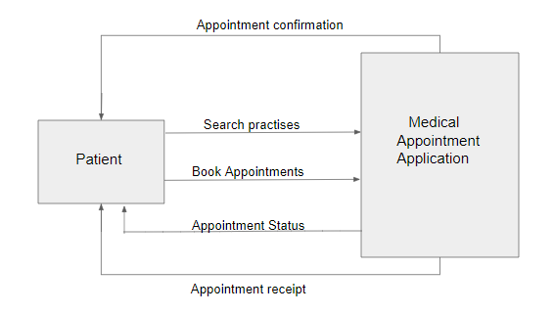

**Fig. 5 Context Diagram**

First the patient searches the consultant, and then makes an appointment. These two steps are from patient to clinician. Then the medical appointment application which we applied is sent to the medical staff to give us the acknowledgement [19]. The appointment status can be seen which is updated from them. And then they sent us the appointment receipt, these two steps are from clinician to patient. And at last appointment confirmation is shown in the application.

1. Result

It gives best user interface because of ahead of time compilation and just in time compilation feature of flutter provides the developers less waiting time to compile.

This application provides you the bunch of options to choose the required specializations and clinician everything from the mobile application itself sitting at home.

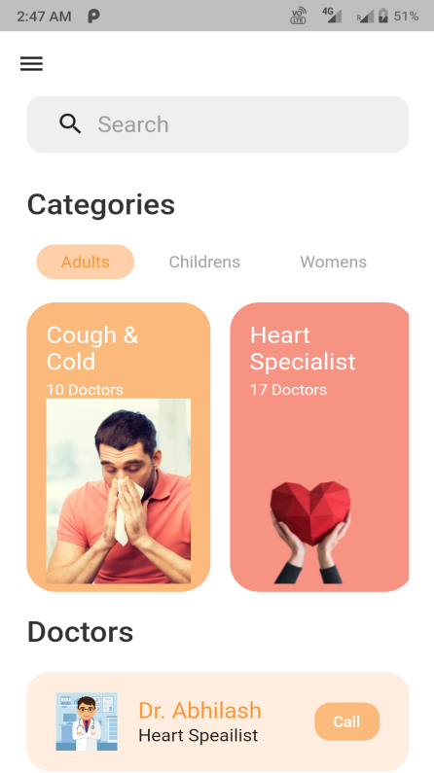

**Fig. 6 Home Screen**

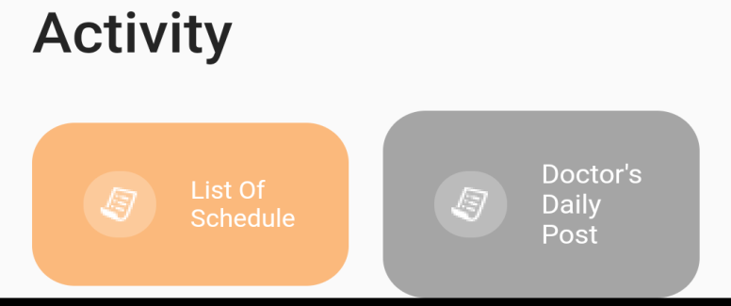

**Fig7. Activity Screen**

Here in this screen, every activity of the user is saved. There are two windows present in this screen. In the first one it shows the list of schedule of total appointments done and the appointments which are left. We can also see if doctor or clinician has sent us a message or instructions to follow here in this second window. We can also pay the consultancy fee plus application charges together in the application itself.

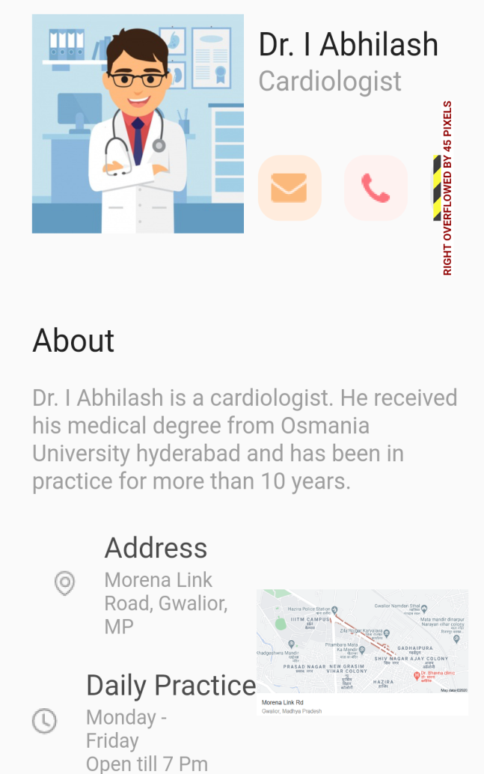

**Fig. 8 Doctor Info Screen**

Here in this screen we can see the description about his bio, address of where he is working present and his working time. Even the map of the address of the hospital is also mentioned here in this screen to help and make it easy for the users. We can mail or call doctor by clicking on the icons shown here in this screen. We can book appointments seeing the specialization and availability of the doctor.

1. CONCLUSION

This paper puts efforts in developing healthcare services digitally. An application has been built in android studio/ visual studio code using flutter editor. This flutter uses dart language to run the code.

Before we book appointments of a consultant from a particular hospital, we have to establish connections with that hospitals so that by making appointments here in this application could notify them, so as to give acknowledgement whether to accept or reject the appointment. This application saves your time as you no longer need to stand in long queues booking appointment. You can book from anywhere, anytime in your device. We can see the doctor’s profile in the application itself and then decide to choose while making appointment. It has efficient and user friendly interface.

It can take some time to get approval from that hospital depending on the doctor’s schedule, so in times of emergency you have to do prior appointments or else you have to go to the hospital directly.

1. FUTURE SCOPE

In this project we provide the option to choose the consultant from the application itself for the users. So to provide more options of clinicians to choose and reduce the waiting time we have to get connect with more no of hospitals, so that you have more number of options to choose to make an appointment of your preference. Bringing secured payment option by doing partnership with trusted payment gateways, to make hassle free payments from the application.

References

1. *A. Hylton III and S. Sankaranarayanan “Application of Intelligent Agents in Hospital Appointment Scheduling System”, International Journal of Computer Theory and Engineering, Vol. 4, August 2012, pp. 625-630.*
2. *Android Application for Healthcare Appointment Booking System Asst. Prof. N. V. Chaudhari, A. Phadnis, P. Dhomane, J. Nimje, A. Sharma[2017]http://www.onlinejournal.in/IJIRV3I3, pp. 194.*
3. *P. Patil, S. Kunhiraman, R. Temkar [2013]: “Functional Description of Online Medical Management System Using Modern Technology”, International Journal of Engineering Science and Innovative Technology, Volume 2, pp. 6.*
4. *N. Puri, A. Gupta, A. K. Aggarwal, V. Kaushal, (2012): ”Outpatient Satisfaction and Quality of Health Care in North Indian Medical Institute”, International Journal of Health Care Quality Assurance, Volume 25 pp. 8.*
5. *[2009]:https://drchrono.com/blog/2015/09/paper-vs-electronic- medicalrecords/: :text=Medical*
6. *https://www.healtheuropa.eu/cloud-based-services-storing-health-datain-the- cloud/93053/ (Extracted date: Nov-07-2020)*
7. *https://dart.dev/guides*
8. *https://flutter.dev/docs*
9. *M. L. Braunstein, ”Health care in the age of interoperability part 5: the personal health record,”2019 in IEEE Pulse, vol. 10, no. 3, pp. 19-23.*
10. *C. C. Y. Poon, W. Gu and Y. T. Zhang, ”Health informatics for low-cost and high-quality health care,” 2010 Annual International Conference of the IEEE Engineering in Medicine and Biology, Buenos Aires, 2010, pp. 1755-1758.*
11. *M. Ma, M. Skubic, K. Ai and J. Hubbard, ”Angel-Echo: A Personalized Health Care Application,” 2017 IEEE/ACM International Conference on Connected Health: Applications, Systems and Engineering Technologies (CHASE), Philadelphia, PA, 2017, pp. 258-259.*
12. *C. Kavitha, A. V. Ramana, S. S. Raj(2012): “Embedded Management System for Out Patient Department”, International Journal of Embedded Systems and Applications (IJESA), Volume 2, pp.3*
13. *S.Goel, Bengaluru (2020): https://www.deccanherald.com/business/budget2020/the-doctor-population-ratio-in-india-is-11456-against-whorecommendation-800034.html*
14. *S. Salaria [2020] :https://timesofindia.indiatimes.com/india/pregnantwoman-with-covid-symptoms-not-admitted-by-8-hospitals-dies-inambulance/articleshow/76240346.cms*
15. *S. Azad (2016): https://timesofindia.indiatimes.com/city/dehradun/Indiahas-2-lakh-unemployed-doctors-who-can-serve-in-rural-areas-if-givenproper- pay-perks/articleshow/54451403.cms*
16. *J. Aghav, S. Sonawane, and H. Bhambhlani “Health Track: Health Monitoring and Prognosis System using Wearable Sensors”, IEEE International Conference on Advances in Engineering and Technology Research 2014, pp. 1-5.*
17. *S. M. A. Wani, S. Sankaranarayanan (2014): “Intelligent Mobile Hospital Appointment Scheduling and Medicine Collection”, International Journal of Computer and Communication System Engineering, Volume 1 pp. 2.*
18. *https://flutter.dev/docs/resources/architectural-overview*
19. *N. Ismail, S. Kasim, Y. Y. Jusoh, R. Hassan, A. Alyani (2017). Medical Appointment Application. Acta Electronica Malaysia, 1(2) : pp. 5-9.*
20. *A. Luschi, A. Belardinelli, L. Marzi, F. Frosini, R. Miniati and E. Iadanza,”Careggi Smart hospital: A mobile app for patients, citizens and healthcare staff,” IEEE-EMBS International Conference on Biomedical and Health Informatics (BHI), Valencia, 2014, pp. 125-128.*
21. *https://www.cleveroad.com/blog/why-use-flutter*
22. *https://medium.com/@bruno.santos/why-to-use-repository-pattern-inyour-application-flutter-549c0739a892*
23. *https://medium.com/@fakhiradevina/flutter-tdd-clean-architecture272373727699*
24. *https://morioh.com/p/f383112bb8d2*
25. *https://everyday.codes/mobile/bloc-in-flutter-implement-clean-flux-likearchitecture/*
26. *https://codewithandrea.com/articles/2019-05-21-wabs-practicalarchitecture-flutter-apps/*
27. *Z. Rebolledo-Nandi, A. Chavez-Olivera, R. E. Cuevas-Valencia, A. ´ Alarcon-Paredes and G. A. Alonso, ”Design of a versatile low cost ´ mobile health care monitoring system using an android application,” 2015 Pan American Health Care Exchanges (PAHCE), Vina del Mar, 2015, pp. 1-4.*
28. *D. Ameta, K. Mudaliar and P. Patel “Medication Reminder And Healthcare – An Android Application”, International Journal of Managing Public Sector Information and Communication Technologies (IJMPICT) Vol. 6, June 2015, pp. 39- 48.*
29. *A. Imteaj and M. K. Hossain, ”A smartphone based application to improve the health care system of Bangladesh,” 2016 International Conference on Medical Engineering, Health Informatics and Technology (MediTec), Dhaka, 2016, pp. 1-6.*
30. *E. A. Alweshail and H. Brahim, ”A Smartphone Application to Provide the Health Care Services at Home,” 2020 3rd International Conference on Computer Applications Information Security (ICCAIS), Riyadh, Saudi Arabia, 2020, pp. 1-5.*